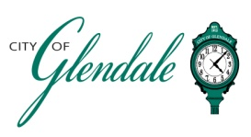
NOTICE OF PUBLIC MEETING
MONDAY, MAY 4, 2026, 6 P.M.
TRAFFIC SAFETY COMMITTEE
TENTATIVE MEETING AGENDA

- MEETING CALLED TO ORDER
- ROLL CALL
- APPROVAL OF APRIL 6, 2026 MINUTES
- CITIZEN COMMENTS
- PARKING ASSESSMENT UPDATE
- TRAFFIC CALMING POLICY DEVELOPMENT
- TRAFFIC CALMING REQUESTS
- REPORTS
- MISCELLANEOUS BUSINESS
- ADJOURNMENT

____________________________
Frank Johnson
City Administrator/City Clerk Posted 3 P.M., April 30, 2026

